**Cover Letter**

July 7, 2015

**Dr. H.D. Smith**

Editor-in-Chief, Marine Policy

Cardiff University, Cardiff, UK

Dear Dr. Smith,

We are excited to submit our manuscript titled “Designing and Financing Optimal Enforcement for Small-Scale Fisheries and Dive Tourism Industries**”** to be considered for publication in Marine Policy.

Illegal, unregulated, and unreported (IUU) fishing is a widespread problem, particularly in small-scale fisheries of the developing tropics. Decisions regarding how much enforcement is necessary, and how to finance that enforcement, can be difficult for managers to make. To address this challenge, we developed a bio-economic model to determine optimal enforcement effort for different types of stakeholders, as well as to determine how to sustainably finance that enforcement. We parameterize this model for an illustrative example of a Caribbean spiny lobster fishery.

We find that the optimal level of enforcement depends on the types of stakeholders who derive benefits from the marine resource, and in particular that fisheries enforcement effort should increase when non-fishery stakeholders are also present, such as dive tourism operators or other groups who value biomass in the water. Additionally, enforcement effort can decrease as the stock recovers and biomass increases. We also find that this optimal level of enforcement can be sustainably financed under steady-state conditions, but that initial capital costs may require outside investment depending on starting stock conditions.

The results provided by this analysis give important insights for managers and practitioners in optimal enforcement design and financing. Furthermore, the methodology provided here could be used as a template for helping managers better design and finance enforcement systems for their own fisheries. We feel that Marine Policy would be an excellent medium for disseminating these findings to managers, practitioners, and researchers around the globe.

Sincerely,

**Gavin McDonald**  
Project Researcher

Sustainable Fisheries Group

Bren School of Environmental Science & Management

University of California, Santa Barbara  
Phone: 805-893-7443  
Email: gmcdonald@bren.ucsb.edu

[http://sfg.msi.ucsb.edu](http://sfg.msi.ucsb.edu/)

**Title:**

Designing and Financing Optimal Enforcement for Small-Scale Fisheries and Dive Tourism Industries

**Author names and affiliations:**

Gavin McDonalda, b, Tracey Mangina, b, Lennon R. Thomasa, b, and Christopher Costelloa

a Bren School of Environmental Science and Management, University of California, Santa Barbara, CA 93106, USA

b These authors contributed equally to the research and development of this paper.

**Corresponding author:**

Gavin McDonald, [gmcdonald@bren.ucsb.edu](mailto:gmcdonald@bren.ucsb.edu), 805-893-7443

**Acknowledgements and funding source:**

We would like to acknowledge and thank the Waitt Institute for their gracious financial support of this project. The Waitt Institute was not involved in the research or development of this project.

**Abstract:**

Effective enforcement can reduce the impacts of illegal, unregulated, and unreported (IUU) fishing, resulting in numerous economic, ecological, and social benefits. However, resource managers often lack the expertise necessary to design an effective enforcement system as well as the monetary resources needed to finance the costs of enforcement, especially in the small-scale fisheries of the developing tropics. Here, a model for a small-scale Caribbean lobster fishery is developed and parameterized in order to design an optimal enforcement system and sustainable financing options for that system. The results demonstrate that the optimal enforcement effort is dependent on both stock status and the types of stakeholders that derive value from the ecosystem services provided by the marine environment. Optimal enforcement effort for three different stakeholder archetypes were considered: 1) a fishing industry only; 2) a dive tourism industry only; and 3) fishing and dive tourism industries. Optimal enforcement effort decreases as biomass increases, and optimal enforcement effort is higher when a dive tourism industry is present compared to when there is only a fishing industry. Additionally, a suite of four financing mechanisms that could be used to sustainably finance the cost of this optimal enforcement level are investigated: 1) fishing license fees; 2) a landings tax; 3) penalties received through the enforcement system; and 4) a tax on dive tourism revenue. The results indicated that in steady state it is possible to fully finance the cost of optimal enforcement using this suite of financing mechanisms. However, some initial external financing will be necessary to cover initial fixed enforcement costs when there is a low starting stock biomass.

**Keywords:**

Optimal fisheries enforcement; financing fisheries enforcement; ; ecosystem services; illegal, unregulated, and unreported (IUU) fishing; small scale fisheries

**Highlights:**

* A bio-economic model is developed and parameterized for an illustrative Caribbean spiny lobster fishery to determine optimal enforcement effort and financing mechanisms given different industries that derive benefits from the resource
* Optimal enforcement effort decreases as biomass increases, and depends on the types of stakeholders deriving benefits from the resource
* It is possible under steady state conditions to sustainably finance an optimal enforcement effort
* There will be initial capital costs to begin an enforcement regime, but these costs can be contemporaneously financed given sufficiently high starting biomass

**Designing and Financing Optimal Enforcement for Small-Scale Fisheries and Dive Tourism Industries**

**1. Introduction**

Illegal, unregulated, and unreported (IUU) fishing is a well-known global problem threatening the sustainability of both large and small-scale fisheries and the health of marine environments (e.g. [1,2,3]). The presence of IUU fishing substantially increases the uncertainty associated with estimating stock status and fishing mortality, which makes determining a sustainable harvest level challenging [4]. IUU fishing has been identified as a major factor contributing to the decline, and in some cases, collapse, of a number of fish stocks [5,6,7]. Other common problems associated with IUU fishing include: ecosystem impacts, economic losses for legal fishermen, and an increased incentive for others to overfish [8,9]. Currently, the extent of worldwide IUU fishing is estimated between 11 and 36 million tonnes annually, valued between 10 and 23.5 billion dollars [4] – a substantial amount considering that the estimated global catch of marine capture fisheries in 2012 was 79.7 million tonnes [10]. Thus, determining effective, feasible methods for eliminating IUU fishing should be considered a high priority.

The primary driver for IUU fishing is economic incentive [9,2]. A fisher who behaves illegally in hopes of financial gain is influenced by the expected costs and benefits of non-compliance [8,11]. An enforcement system, defined as the surveillance of compliance with regulations and the prosecution of those who do not comply with regulations [12,13], can help to decrease the expected benefits from illegal activity and deter such behaviors. The expected profitability of illegal fishing is a function of the enforcement system, and is inversely related to the enforcement effort and probability of detection, the probability of prosecution, and the cost of the penalty (measured in fines, the loss of future earnings due to revoked fishing privileges, etc.) [11]. Therefore, as any of these three aspects increase, the expected profitability of illegal fishing will decrease. The ability for an enforcement system to effectively deter IUU fishing in a particular fishery will also depend on the status of the stock, social and economic conditions in the fishery, regulations being enforced, and spatial characteristics of the fishery [14,13,11,15]

Effective enforcement of a fishery management system has the potential to address the ecological, economic, and social implications of illegal fishing [16,17,18,19,10]. Unreported catch can undermine management efforts by resulting in unaccounted harvests and greater levels of uncertainty, which can significantly affect biomass levels – together, proper management and effective enforcement can reduce this and other negative ecological impacts and assure some level of conservation [19,20]. The benefits of conservation may be economic, for example if a dive tourism industry is present [21], and also social by providing increased developmental, educational, recreational, spiritual, cultural, and research opportunities [22, 23]. The economic and social benefits of reducing illegal fishing are likely to be substantial for developing nations where IUU fishing threatens both food security and livelihoods for those who depend on local fisheries as a protein source and means of income. Thus, effective enforcement can help to recapture dissipated fisheries benefits [12,61]. In the absence of IUU fishing, proper management of a stock will most efficiently maximize revenues [18]. Despite the clear benefits most fisheries would receive from improved enforcement, many fisheries lack an adequate level of enforcement, particularly in small-scale fisheries in developing countries [24, 25].

Major barriers to more pervasive and effective enforcement include significant upfront capital costs and high operational costs of ongoing implementation [26,27]. Enforcement is generally the most expensive aspect of fishery management costs and increasing enforcement effort is often costly [13,11]. This is particularly a problem in small-scale fisheries in developing countries that depend on coastal fishing for livelihoods and food security, yet lack the resources to pay for enforcement [28, 29]. Often, governments, NGOs, private investors, or a combination provide funding at the onset of new fisheries management initiatives but are unable to fund ongoing enforcement costs [30]. For this reason, it is important to design a sustainable system that can eventually be self-financing. This not only ensures the sustainability of the fishery over time, but can also help to attract the upfront investments needed at the onset of enforcement reform. Under a cost-recovery system in which the sectors benefiting from enforcement are responsible for financing this service, potential sources of funding for ongoing enforcement effort include license fees, taxes on landings, fines from illegal activity, and, if applicable, taxes on a relevant tourism industry such as diving. Cost-recovery has been used to finance the costs associated with fisheries management in the United States [62], Australia, New Zealand, Iceland, Canada [63], and Namibia [64]. Other funding sources for fisheries management include local and national government funding and foreign investment [65]. In many cases, funding is not available for fisheries enforcement. While cost-recovery programs are not yet widespread in small-scale fisheries of the developing tropics, this type of system has the potential to provide funding for fisheries enforcement and management activities in locations where other funding sources either do not exist or do not provide adequate resources for effective management.

The basic economic theory of fisheries enforcement has been previously developed and reported in the literature [31]. This theory posits that instituting a particular enforcement system in a fishery leads to a certain probability that fishers operating illegally will be apprehended and penalized. The probability of receiving a penalty is a function of the enforcement effort applied, the effectiveness of the particular enforcement method in terms of detecting violators, and the likelihood of prosecution. As profit maximizing individuals, illegal fishers take this information into account by including the expected penalty cost into their private benefit function and adjusting their fishing effort accordingly. It should be noted that this theory relies on the assumption that fishers are profit-maximizing, which may not always be the case. Other non-monetary factors may increase compliance including moral standards [26], social punishments for rule violators including ostracism and social degradation [56, 57], fisher involvement with co-management [58], and fisher participation in cooperatives [59]. While the effect of these additional factors is harder to quantify, these factors could be prevalent in small-scale fisheries and should be considered when trying to understand the effect of enforcement for any particular fishery. If these factors are strong enough, the assumption of profit-maximization may not always hold.

Previous studies examined how the optimal enforcement levels depend on stock status, the economic parameters of a fishery, and the enforcement system in place [32]. This optimal level was determined by maximizing the total social benefits in the fishery, accounting for both fishing profits as well as the cost of enforcement. This study investigates optimal enforcement levels in the context of a tropical, small-scale lobster fishery and builds upon previous research in two important ways. First, the optimal enforcement effort level is determined as a function of the lobster stock status for three different stakeholder archetypes common in tropical small-scale fishery settings, each with private industries deriving benefits from the stock: 1) lobster fishing industry only; 2) dive tourism industry only; and 3) lobster fishing and dive tourism industries (Figure 1). Second, the model is used to explore the potential of sustainably financing enforcement in a small scale setting through financing mechanisms potentially available in small-scale fisheries: 1) fishing license fees; 2) a landings tax; 3) penalties received through the enforcement system; 4) a tax on dive tourism revenue. This analysis may be used to help stakeholders determine optimal enforcement levels for a fishery given the status of the stock and stakeholder archetypes, as well as inform sustainable enforcement financing mechanisms for small-scale fisheries.

**2. Methods**

A bio-economic model parameterized for a small-scale Caribbean spiny lobster fjshery (*Panulirus argus*) is used to investigate the following questions: 1) how will optimal enforcement and fishing effort change given the stakeholder archetype and status of a stock; and 2) how can this optimal enforcement level be financed. For each stakeholder archetype in this small-scale fishery setting, a dynamically optimal legal harvest level for the lobster fishery is derived assuming no illegal fishing occurs. This optimal harvest level, referred to as the lobster fishery’s Total Allowable Catch (TAC) is a function of lobster stock biomass and maximizes industry-derived benefits. Once the optimal, legal TAC for the fishery is determined, illegal fishing is introduced to determine an optimal enforcement level that maximizes a net social benefit function, which includes both industry benefits and enforcement costs. As part of this optimization, the level of illegal fishing that occurs each year is determined as a function of biomass and enforcement effort. Finally, the model is used to examine how and over what time scale the costs of enforcement can be financed through cost-recovery using the four financing mechanisms. Parameter values used in the models are derived from other published studies or personal communications and are used to represent a small-scale lobster fishery in the Caribbean (Table 1).

*2.1 Bio-Economic Model*

*2.1.1 Biological Model*

A simple discrete logistic model [33] is used to describe population growth of the Caribbean spiny lobster *Panulirus argus* and calculate stock biomass (*B)* at an annual time step (*t*) after total annual catch (*Qt*) from the fishery has been removed:

$B_{t+1}= B_{t}+rB_{t}- \frac{rB_{t}^{2}}{K}- Q_{t}$ (*1*)

Where *r* is the estimated intrinsic growth rate parameter of a tropical lobster population (Morris 2010), and *K* is the lobster population’s carrying capacity, derived from estimated population parameters of a Caribbean lobster stock (Horsfeld et al. 2013).

*2.1.2 Economic Model*

A modification of the economic model described in [34] is used to calculate revenue generated from a fishing industry and dive tourism industry under the 3 stakeholder archetypes: 1) fishing industry only; 2) dive tourism industry only; and 3) dive and fishing industries. Revenue generated from both the fishing and dive tourism industries are assumed to be functions of lobster stock biomass (*B*).

*2.1.2.1 Dive Tourism Industry*

In the Caribbean region, divers prefer to frequent areas with more abundant marine life [21]. Although no data exists on the general relationship between marine life abundance and how often an area is frequented by divers [21], we use the following model from Sala et. al for calculating the marginal value (*Pt*) of additional dives:

$P_{t}=α_{0}+α_{1}D_{t}+α_{2}B_{t}$ (*2*)

Where *Dt* is the number of dives occurring in each year *t*, *Bt* is the lobster biomass in each year, *α0* is a dive tourism value parameter that represents the value of the first dive even without any lobster biomass in the water, *α1* is a dive tourism value parameter that is less than 0 to reflect the assumption that additional dives are marginally less valuable, and *α2* is a dive tourism value parameter that is assumed to be greater than 0 to reflect the assumption that the value of each dive increases linearly with increasing biomass. Values for these parameters were assumed and borrowed from the estimated relationship between dive industry revenue and fish biomass in the Medes Island Marine Reserve [21]. It follows from Equation 2 that the number of dives that maximizes dive tourism revenue is calculated as follows:

${ D}_{t}=\frac{α_{0}+α_{2}B_{t}}{-2α_{1}}$ (*3*)

Using Equations 2 and 3, the optimal price per dive is therefore calculated as follows:

$u_{t}= α_{0}+\left(\frac{α_{0}+α_{2}B_{t}}{-2}\right)+α_{2}B_{t}$ (*4*)

And finally, the total revenue generated from the dive tourism industry in archetypes 2 and 3 is calculated using the following relationship. By including this relationship in the profit functions for archetypes 2 and 3, profits just generated by harvesting fish out of the water, but also are generated when fish are left in the water. This changes the dynamic for determining optimal catch levels and enforcement effort.

$R_{t}= D_{t}u_{t}$ (*5*)

*2.1.2.2 Fishing Industry*

The model is used to determine a dynamic optimal legal harvest level (or TAC, denoted by $Q_{t}^{*}$) for the lobster fishing industry and the corresponding actual harvest response that includes illegal fishing (*Qt*) using a 2-step optimization process. For archetype 2, which assumes only a dive industry is present, $Q_{t}^{*}$*=* 0because no legal fishery exists under this archetype. For archetypes 1 and 3, $Q_{t}^{*}$ is determined by maximizing the present value of a private industry benefit function that includes the fishing industry, the dive industry, or both ($π^{*}$, equations 6 and 7 below). These equations are used to find the optimal TAC, as a function of lobster biomass, that maximizes net present value (NPV) of the fishing and/or diving industries present assuming that no illegal fishing occurs. The private lobster fisher benefit function under archetype 1 ( $π_{t,1}^{*})$ is defined as:

$π_{t,1}^{*}=pQ_{t}^{*}- c{\frac{Q_{t}^{*}}{B_{t}}}^{2}- L_{t} - v_{t}Q_{t}^{*}$ (*6*)

Where, *p* is the price paid per unit weight of total legal lobster catch (TAC) (USD/kg), *c* represents the cost of lobster fishing (USD/kg), *L* is the cost of fishing licenses for the entire lobster fishing fleet (USD), and *v* is the tax paid per unit weight of catch of lobster (USD/kg). The values of the *p*, c, *L*, and *v* parameters are estimates based on the price of lobster, estimated cost of fishing, and cost of licenses in the Barbuda spiny lobster fishery (personal communication).

The private combined lobster fishing and dive tourism benefit function under archetype 3 ( $π_{t,3}^{*})$ is defined as:

$π_{t,3}^{*}=pQ_{t}^{*}- c{\frac{Q_{t}^{*}}{B_{t}}}^{2}- L_{t} - v_{t}Q_{t}^{*}+ (1-w_{t})R_{t}$ (*7*)

Where *wt* is an assumed tax placed on the dive tourism industry revenue.

Given the optimal TAC calculated above ($Q_{t}^{*})$, the actual total annual catch response (*Qt*) landed by both legal and illegal fishing under is determined by maximizing a modified private industry benefit function ($π$) that allows for illegal fishing to occur (*Qt* > ). The private industry benefit function used to determine $Q_{t}$ under each archetype are defined as:

${ π}_{t,1}=pQ_{t}-c{\frac{Q_{t}}{B_{t}}}^{2}-fϕ\left(e_{t}\right){(Q}_{t}$ $- Q_{t}^{*})- L_{t} - v_{t}Q_{t}^{*}$ (*8*)

$π_{t,2}=(1-w_{t})R_{t}$ (*9*)

$π_{t,3}= pQ_{t}-c{\frac{Q_{t}}{B_{t}}}^{2}-fϕ\left(e_{t}\right){(Q}_{t}$ $- Q_{t}^{*})- L_{t} - v_{t}Q_{t}^{*}+ (1-w_{t})R_{t}$ (*10*)

Where, *f $ϕ$*(*et*)( ) represents the total expected fine illegal fishers will be levied (USD) given a fine parameter *f* (USD/kg), the probability of receiving a fine ( $ϕ)$ given the enforcement effort level (*e*), and the amount of landings that exceed the legal harvest level. The method for determining the enforcement level *e* is discussed in Section 2.2.2. Theactual catchcalculated each year (*Qt*) is incorporated into the biological portion of the model to calculate the lobster biomass (*Bt)* for the following year (Equation 1).

*2.2 Enforcement Model*

*2.2.1 Enforcement Parameters*

The probability of an illegal fisher being detected and fined ( $ϕ)$ is assumed to be a function of the enforcement effort level (*et*) [34]:

$ϕ_{t}\left(e_{t}\right)=a+b ln(e_{t})$ (*11*)

Where *a* represents the detection probability at the maximum enforcement effort level (which occurs when *e* = 1), and the shape parameter *b* is borrowed from the enforcement detectability of patrol vessels in the Kattegat and Skagerrak nephrops fishery (COBECOS 2009). The probability of a patrol vessel detecting illegal fishing was assumed to be proportional to the amount of area it is able to cover in a day. Assuming a vessel speed of 15 knots per hour and a fishing area in a small-scale fishery of 886 km2 , one vessel could cover 22,240 m2 in 8 hours (assuming a vessel can cover a 22.5 km swath and an 11.25 m line of vision on either side of the vessel), or 25% of the total fishery area. It is therefore assumed that 3 patrol vessels could collectively patrol 75% of the fishery area within 8 hours of surveillance at an enforcement effort of 1. Assuming fishers operate 24 hours per day, a maximum detection probability of 25% is found when enforcement effort is equal to 1. The natural log of enforcement effort is used to change the shape of the curve and represents diminishing returns with marginal increases in enforcement effort – this is an assumption the authors make and consistent with previous studies (COBECOS 2009). It is also assumed that vessels detected illegally fishing will be apprehended, prosecuted, and fined.

The cost of enforcement (*C*) given the enforcement effort level (*e*) is defined as:

*Ct*(*et*) = *C0* {*t* = 0} (*12*)

*Ct*(*et*) = *npb* *et* *hmax* (*Cfuel* + *npo* *Cpo*) {*t* > =1}

Where *C0* represents fixed enforcement costs associated with the investment in enforcement materials. *Ct* for *t* ≥1 describes annual variable costs, where *npb* is the number of patrol boats, *e*is the enforcement level ranging from 0 (no enforcement) to 1 (maximum enforcement), *hmax* represents the maximum number of patrol vessel hours in a year, *Cfuel* is the hourly fuel cost of operating one patrol boat, *npo* is the number of patrol officers per patrol boat, and *Cpo* is the hourly rate per patrol officer.

*2.2.2 Determining Optimal Enforcement Effort and Financing Revenue Streams*

To determine the optimal enforcement effort for each archetype, net social benefit functions are first defined for each archetype (*xt,1 xt,2* and *xt,3*) that include: the private industry benefit(s) for that particular archetype (*π,* defined in Equations 8, 9, and 10 above); the costs of enforcement given enforcement effort (*C*(*e*)); and financing revenues generated by a fishing license fee, a landings tax, penalties received through the enforcement system, and a tax on dive tourism revenue:

+ (*13*)

$x_{t,2}= {π_{t,2}- C}_{t}\left(e_{t}\right)+ w_{t}R_{t}$ (*14*)

+ (15)

For each archetype, the dynamic optimal enforcement effort (*e*) is determined by finding the enforcement effort as a function of biomass that maximizes the NPV of social benefit *x* over a time period of a twenty-year time horizon and a discount rate of 0.05. Twenty years was chosen in order to allow the system to reach equilibrium conditions, while it is also assumed to be short enough to represent a meaningful time horizon for the social planners of this illustrative Caribbean lobster fishery. The total costs of enforcement alongside the financing revenue streams are also found at each time step to determine at what time (if any) social planner revenue exceeds enforcement costs. This is later referred to this as the social planner break-even point.

*2.2.3 Determining Enforcement Effort Necessary to Eliminate Illegal Fishing*

An additional analysis is conducted to determine the enforcement effort, as a function of biomass, necessary to completely eliminate illegal fishing and thus perfectly achieve the legal harvest level for each archetype. These enforcement levels are allowed to be higher than the optimal levels. For each archetype, the additional cost needed to achieve this enforcement effort is also found. This enforcement effort is thus not economically optimal, but may be more desirable from a social or conservation perspective.

*2.3 Sensitivity Analyses*

*2.3.1 Impacts of Initial Stock Status*

The impact of starting stock status (*Bt*/*BMSY* at *t*=1) on optimal enforcement effort levels and costs, social planner break-even point, financing revenue streams, and net social benefits is investigated by running the bioeconomic model and enforcement model for initial stock levels of 0.4*BMSY*, 0.8*BMSY*, 1.2*BMSY*, 1.6 *BMSY*, and 2 *BMSY* (Table 2). This is done for each of the three archetypes.

*2.3.2 Impact of Financing Mechanism Parameters*

The sensitivity of the results to the landings tax, enforcement fine, tourism revenue tax, and fishing license fee parameter values is investigated.Each parameter is run over the range of values specified in Table 2 while all other parameters are held at their base value.

**3.0 Results**

*3.1 The impact of biomass and archetype on optimal legal catch levels, optimal enforcement levels, and illegal fishing effort*

For each stakeholder archetype (Figure 1), the model finds the optimal annual TAC (*Qt\**) and dynamic optimal enforcement effort as functions of stock biomass (*B/BMSY*)(Figure 2a and Figure 2b)*. Q\** is affected by the biomass and increases as lobster biomass increases. Under archetype 1, the optimalTAC is zero when lobster stock biomass is less than or equal to *B/BMSY* of 0.6. Similarly, the optimalTAC under archetype 3 is zero when lobster biomass is low, but increases when biomass is above *B/BMSY* = 1. For biomass levels in whichthe optimalTAC is greater than zero, fishing effort under archetype 1 is greater than effort under archetype 3 by about 0.1 at each biomass level.

For all three stakeholder archetypes, optimal enforcement effort is highest when lobster biomass is low, and decreases as biomass increases (Figure 2b). Optimal enforcement effort is always the highest in archetype 2, which consists of only a dive tourism industry. At low biomass levels, the optimal enforcement levels for archetypes 1 and 3 are the same. At these biomass levels, enforcement effort for archetypes 1 and 3 is about 0.23 while enforcement effort under archetype 2 is only slightly higher at about 0.24. However, with higher biomasses (*B/BMSY* > 0.6), optimal enforcement levels are higher under archetype 3 than archetype 1. When *B/BMSY* = 1, enforcement effort is equal to 0.17, 0.24, and 0.23 for archetypes 1, 2, and 3 respectively. When *B/BMSY* = 2, enforcement efforts is equal 0.14, 0.18, and 0.16 for archetypes 1, 2, and 3 respectively. Notably, optimal enforcement efforts are always substantially lower than 1, or the maximum possible effort.

The model is also used to determine how the optimalTAC and optimal enforcement effort affect illegal fishing effort (Figure 2c)*.* For all three archetypes, illegal fishing effort is influenced by archetype, biomass level, and enforcement effort. Illegal fishing effort increases as the biomass increases, reflecting increased profitability with more fish in the water. For low biomass levels (*B/BMSY* ­≤ to 0.8), illegal fishing effort under all three archetypes is zero. For higher biomass levels, illegal fishing effort is highest under archetype 2, followed by 3 and 1 respectively. For archetypes 1 and 3, the illegal fishing effort is relatively minimal regardless of stock status. Archetype 2, which has a legal catch quota of zero, has significant illegal fishing effort above *B/BMSY* = 1.

Finally, the model is used to determine the enforcement effort and associated enforcement cost necessary to fully eliminate illegal fishing for each archetype (Figure 2d and Figure 2e). At stock conditions below 0.8*BMSY*, the economically optimal enforcement effort already eliminates illegal fishing, so there is no need for additional enforcement. Above this biomass, however, the enforcement effort necessary to eliminate illegal fishing is higher than the economically optimal enforcement effort for all three archetypes. Consequently, the cost of enforcement would be higher under all archetypes if managers were to eliminate illegal fishing. The additional enforcement effort necessary to eliminate illegal fishing at *B/BMSY* = 2 is 0.005, 0.056, and 0.0056 for archetypes 1, 2, and 3 respectively. The corresponding additional annual enforcement cost is $2,721, $30,863, and $3,125 for the archetypes 1, 2, and 3 respectively. This additional enforcement effort, and associated cost, is highest under archetype 2. Since by definition there is no legal fishing allowed under this archetype at all, this archetype requires the highest enforcement effort to fully disincentivize illegal fishing.

*3.2 Financing Enforcement*

While the results demonstrate that in many cases it is economically optimal to monitor and enforce a fishery, financing that enforcement effort is a perennial challenge for many of the world’s fisheries. There are many mechanisms through which the beneficiaries of enforcement (i.e., legal fishers or divers) could be used to help finance enforcement – a small set of them is examined here. The four social planner revenue streams analyzed in this study include the following: 1) a license fee ($18/year/fisher); 2) a landings tax of 5%; 3) fines from illegal fishing ($100 per kg of illegal harvest, or 10 times the legal ex-vessel price); and 4) a tax on dive tourism revenues of 5%. These values were chosen arbitrarily, and sensitivity analysis for each of the four financing parameters were conducted. When projecting the expected enforcement costs and social planner revenue streams over time, it is found that these values differ based on the starting stock biomass and the stakeholder archetype. For all three archetypes, higher starting stock biomasses lead to lower NPVs of enforcement costs and higher NPVs of financing revenues over a twenty-year time horizon (Figure 3). Under archetypes 1 and 3, the financing stream that generates the most revenue for the social planner is the landings tax. Under archetype 2, fines generated by enforcement represent the highest fraction of social planner revenue, which reflects the fact that all fishing activities are illegal under archetype 2. Revenue generated by a fishing license fee was negligible compared to other financing streams for archetypes 1 and 3. Importantly, it is found that the NPV of revenues exceeds the NPV of enforcement costs for every archetype and starting stock condition, indicating that this suite of financing mechanisms can fully finance optimal levels of enforcement regardless of the industries present and starting stock conditions.

However, while the NPV of social planner revenues exceeds the NPV of enforcement costs for every scenario, the social planner break-even point (the year in which the NPV of social planner revenue first exceeds the NPV of enforcement costs up to that point) varied depending on the archetype and starting stock biomass (Figure 4). Higher starting stock biomasses lead to shorter amounts of time before reaching break-even points for all archetypes. However, if the starting stock biomass is at least equal to 1.4*BMSY ,*1.0*BMSY,* and 1.6*BMSY* for archetypes 1, 2, and 3 respectively, the break-even point occurs in the first year. This indicates that for these starting conditions, optimal levels of enforcement can be contemporaneously financed using this suite of financing mechanisms. In cases with a break-even point of one year or greater, external financing is needed to cover the initial fixed enforcement costs.

Sensitivity analyses indicate the dependency of these results on the various financing parameters that can be adjusted by the social planner (Figure 5 through Figure 7). These figures demonstrate the tradeoffs that social planners must consider when designing their financing mechanisms. The four parameters not only impact the industry NPV, but also the social planner break-even point for financing the cost of enforcement. By increasing the landings tax in archetypes 1 and 3, the social planner decreases the industry NPV but also shortens the time it takes to reach the break-even point under low starting biomass conditions. However, increasing the landings tax above 15% has no impact on the break-even point while continuing to negatively impact industry NPV. Increasing the enforcement fine for all 3 archetypes increases the industry NPV while also decreasing the time it takes to reach the break-even point, leading to win-win policy. However, above a certain enforcement fine (20 times the landings price), there are negligible impacts on industry NPV. In addition, there are negligible impacts on the social planner break-even point when the enforcement fine is between 10 and 15 times the landings price in archetype 1 (depending on the starting stock biomass) and about 15 times the landings price in archetypes 2 and 3. In archetypes 2 and 3, increasing the dive tourism tax decreases industry NPV but also slightly shortens the time it takes to reach the break-even point. In archetypes 1 and 3, increasing the fisher license fee slightly decreases the industry NPV while shortening the time it takes to reach the break-even point for biomass levels ≤ 1.2 *BMSY*.

**4. Discussion**

*4.1 The impact of biomass and archetype on optimal legal catch levels, optimal enforcement levels, and illegal fishing effort*

As expected, the optimal TAC for the small-scale lobster fishery example is dependent on the stock biomass and the stakeholder archetype. Under all stakeholder archetypes, the optimal TAC increases with increasing stock biomass. The optimal TAC for the lobster fishery was always lower when a dive tourism industry was present, which makes intuitive sense; in this case, the value that the tourism industry receives from lobster biomass in the water is sufficient to reduce the economically optimal TAC and increase enforcement effort. Additionally, it makes intuitive sense that the optimal level of enforcement is not constant over time but rather depends on the stock status of the target fishery and/or species of interest for the dive tourism industry. At low levels of stock biomass, the potential improvements to the stock and the net present value of benefits that those improvements make it worthwhile to spend more money on costly enforcement. In other words, the shadow value of the biomass of an overfished stock is higher than that of biomass from a healthy stock in our lobster fishery example. At higher stock biomass levels, increases in stock biomass are smaller and thus it is more efficient to spend less money on costly enforcement, which may only yield a small increase in stock biomass. This result is consistent with previous findings in the literature [32]. This result has practical implications for managers of small-scale fisheries who hope to implement an economically efficient enforcement system, especially in fisheries that are currently overfished; enforcement effort should be highest when the stock biomass is lowest (i.e. overfished), and can decrease over time as the status of the stock improves. This scenario may require a higher initial investment for enforcement costs, but lower ongoing costs.

For the purposes of this paper, the focus was placed on extractive and non-extractive direct use values generated by a fishing industry and dive tourism industry, respectively. However, there may be additional non-use values, such as the intrinsic existence value of a healthy ecosystem and conservation value [37, 39]. When considering the optimal level of enforcement, it may be desirable to include these non-use values in the social welfare function since these values can be considerable [37, 40]. Importantly, while there are a number of non-market valuation methods for quantifying these types of non-use values, these approaches are data-hungry and associated with strong assumptions and caveats [41,42]. However, even without explicitly including non-use values in this analysis, the example of dive tourism is demonstrative of how placing economic value on biomass in the water for whatever reason will likely decrease the optimal legal fishing quota and increase the optimal enforcement effort.

*4.2 Financing Enforcement*

Improved enforcement of a sustainable fishery management plan can increase industry benefits, but is often associated with high costs [12, 31, 44]. On average, enforcement costs are estimated to be between 3-30% of total fishery value [45, 46]. However, as the model demonstrates, by establishing an effective sustainable financing plan, even when there is no dive tourism industry, the cost of enforcement can be sustainably financed. For the recovery of a depleted stock, enforcement costs will be high at first but will decrease over time and can be recovered over a period of time as industry benefits increase [12, 47]. Fisheries in Australia, New Zealand, Namibia and Canada have all successfully implemented mechanisms to recover some portion of enforcement costs from the fishing industry, and a cost-recovery program to finance fisheries management has been developed in Uganda [Keizire 2001; FAO 2007] [46, 48]. Recovering enforcement costs from fishing industries not only increases the financial resources available for enforcement, but it reduces the burden of cost to non-benefitting community members and creates a positive feedback loop because fishers are more likely to demand efficiency in services they are funding [12, 47]. The fishing industry in Australia became more involved in the management process when fishing industry benefits were used to finance enforcement and management, which resulted in higher acceptance and compliance of management measures by fishermen [48]. In New Zealand, recovering enforcement costs from the fishing industry led to an increase in enforcement effort over time without an increase in costs because the fishing industry was incentivized to become more involved in the enforcement process [47].

The tradeoffs between financing mechanisms should be carefully considered in light of fishery characteristics and management goals [12, 49]. The costs and feasibility associated with the mechanism, how the mechanism will distribute costs among users, and incentives that may be generated should be determined [49]. For example, a license or fishery participation fee may be relatively simple and cheap to collect, but when a wide range of fishing capacity exists between participants, smaller-scale fishers often suffer a disproportionate loss in profits and may be forced out of the fishery [46]. In other cases, a participation fee may have the desired effect of limiting participation in a fishery [12]. A mechanism to tax a fishers’ input (effort) or output (catch) unit is more likely to evenly distribute the costs of enforcement among participants [12]. However, input taxes may unintentionally result in a total fishing effort increase because fishers are incentivized to increase untaxed effort units to make up for lost profits [46]. In this study, the landings tax was the largest available financing revenue stream for archetypes 1 and 3. A landings tax has been an effective method of recovering enforcement costs in fisheries with an adequate level of monitoring and enforcement [50]. This approach, however, assumes that landings are being fully and accurately reported, and may create incentives for underreporting. A landings tax on a local fishery in Tanzania created an incentive for fishers to underreport landings to reduce their landings tax [51]. Export taxes are another option for cost recovery, but also have unintended consequences; such a tax may negatively impact the value of the fishery if it causes sellers to sell a larger portion of catch locally to avoid the export tax, thus flooding the market and reducing product value [46].

In this analysis, the break-even point was highly dependent on the archetype and types of stakeholders contributing to cost recovery, especially at low stock conditions. This demonstrates the importance of having all benefiting parties, not just fishing industries, contribute to enforcement cost recovery [50]. This is an especially important consideration for areas where the poverty level of fishers makes recovering enforcement costs through the fishing industry alone unfeasible [52]. These same areas often lack financial resources to adequately protect their marine resources [30] yet marine related-tourism can offer an opportunity to improve the local economy [49, 53]. For example, in Mozambique a survey of divers revealed that the majority of dive tourists were attracted to the area because of the healthy marine ecosystem and the presence of certain species [54]. However, the species that attracted the divers were also targeted by a fishery with poorly enforced management. In this case, using revenue generated from the tourism industry to finance fisheries enforcement would likely yield large benefits to both industries.

It is not uncommon for managers to use revenue generated from the tourism industry to finance the costs of enforcement of a designated spatial area or marine reserve [49, 55]. However, the surrounding fisheries may not receive spillover benefits from these protected areas if management and enforcement outside of designated spatial areas is inadequate. If revenue generated from tourism associated with a marine reserve could be used to finance fisheries enforcement outside of the marine reserve as well, the benefits of marine reserves to fisheries would likely increase. Although the literature does not show documented examples of tourism revenue can be used to enforce fisheries regulations within fished areas, studies have shown that tourists may be willing to pay more for their experiences [52, 53] this increased revenue could be used to pay for enforcement of management within fished areas.

*4.3 Assumptions*

Importantly, there are a number of assumptions that if changed could impact the results of the model. First, while we assume that fishers are purely profit-maximizing and that their expected benefits are influenced by the probability of being prosecuted and fined, there are other factors that might influence fishing behavior including moral principles and social pressure/norms [26,56,57]. Where appropriate, the social costs of illegal fishing could be examined by adding an additional cost parameter to the expected benefit function [24, 26]. Other factors that might affect fisher behavior include perceived fairness, perceived legitimacy of rules and the management authority, and fisher involvement in management design and implementation [58]. Co-management and other arrangements such as cooperatives [59] that incorporate fisher participation in the design and implementation of management can strengthen perceived fairness, and possibly therefore compliance rates [58]. These considerations can especially relevant when designing new management and enforcement systems in small-scale fisheries. Moreover, the existence of these behavior-influencing factors suggests that there might be other ways to influence compliance rates besides traditional monitoring and enforcement, such as implementing programs that influence ethical codes and strengthen user participation, perceived fairness, and perceived legitimacy [26]. This could be a cost-effective alternative or supplement to increased enforcement in small-scale resource-limited fisheries.

A number of institutional assumptions are also made that might be violated, especially in small-scale fisheries with limited infrastructure. First, it is assumed that institutions are in place to facilitate the collection of license fees, taxes, and fines, and that a social planner is able to use these funds on enforcement costs. In reality, these management institutions might not exist, and are associated with implementation costs and operating costs of their own which were not included in this model. Second, it is assumed that the cost of prosecution and fine collection is zero, when in reality the prosecution costs can be substantial and may include attorney or court costs [60]., It is also assumed that illegal fishers who are caught are prosecuted, convicted, and fined, and that their fines are immediately collected. This is likely not the case in many fisheries in the developing tropics. One potential problem is that many fishers simply lack the financial resources to pay the fine. Another problem is low levels of prosecution and conviction rates [60]. To examine this in the model, one could add an additional probability parameter to the expected benefits function that would make expected cost of illegally fishing dependent on the probability of being prosecuted in addition to the probability of being detected and the level of the fine [11]. Since the likelihood of being prosecuted is likely less than one (which may be the case for example in some regions where the Corruption Perceptions Index is high), it is easy to imagine scenarios in which fishers are relatively undeterred by the threat of enforcement. In these cases, social benefits can decline, stocks can become or remain overfished, and industry profits can suffer. These potential issues suggest that broader institutional and political changes may be needed before an enforcement program is able to operate effectively.

**5. Conclusion**

This analysis helps inform how stakeholder archetypes and biomass levels influence the optimal harvest and enforcement effort in fisheries, with a case study parameterized to a small-scale Caribbean lobster fishery. The results demonstrate that optimal enforcement effort should be highest for low biomass, and can decrease as the stock rebuilds. Optimal enforcement also depends on the ecosystem services and stakeholder receiving benefits from those services, and is higher when dive tourism (or other sector that values biomass of fish in the water) is present. In depleted or collapsed initial stock conditions, the social planner revenue will not be sufficient to contemporaneously finance the optimal enforcement effort, which suggests that additional capital investment will likely be needed at the onset of new enforcement strategies. However, the social planner can eventually pay back external investors in full, as well as sustainably finance ongoing enforcement efforts through the use of a landings tax, enforcement fines, fisher licensing fee, and dive tourism tax.

**6.0 References**

[1] Evans DW. The consequences of illegal, unreported and unregulated fishing for fishery data and management. FAO Fisheries Report (FAO) 2001; 9p

[2] Sumaila UR, Alder J, Keith H. Global scope and economics of illegal fishing. Marine Policy 2006; 30: 696–703. doi:10.1016/j.marpol.2005.11.001.

[3] Varkey DA, Ainsworth CH, Pitcher TJ, Goram Y, Sumaila R. Illegal, unreported and unregulated fisheries catch in Raja Ampat Regency, Eastern Indonesia. Marine Policy 2010; 34: 228–36. doi:10.1016/j.marpol.2009.06.009.

[4] Agnew DJ, Pearce J, Pramod G, Peatman T, Watson R, Beddington JR, Pitcher TJ. Estimating the worldwide extent of illegal fishing. Plos One 2009; 4(2): e4570

[5] Safina C, Klinger DH. Collapse of bluefin tuna in the Western Atlantic. Conservation Biology: The Journal of the Society for Conservation Biology 2008; 22: 243–6. doi:10.1111/j.1523-1739.2008.00901.x.

[6] Field IC, Meekan MG, Buckworth RC, Bradshaw CJ. Protein mining the world’s oceans: Australasia as an example of illegal expansion-and-displacement fishing. Fish and Fisheries 2009; 10: 323–8. doi:10.1111/j.1467-2979.2009.00325.x.

[7] Öztürk B. Some remarks of Illegal , Unreported and Unregulated ( IUU ) fishing in Turkish part of the Black Sea 2013; 19: 256–67.

[8] Schmidt C-C. Economic Drivers of Illegal, Unreported and Unregulated (IUU) Fishing. The International Journal of Marine and Coastal Law 2005; 20: 479–507. doi:10.1163/157180805775098630.

[9] Gallic B Le, Cox A. An economic analysis of illegal, unreported and unregulated (IUU) fishing: Key drivers and possible solutions. Marine Policy 2006; 30: 689–95. doi:10.1016/j.marpol.2005.09.008.

[10] FAO. State of World Fisheries and Aquaculture: Opportunities and challenges. Food and Agriculture Organization of the United Nations. Rome, 2014.

[11] Arnason, R. Fisheries management and operations research. European Journal of Operational Research 2009; 1*9*3: 741-751.

[12] Wallis P, Flaaten O. Fisheries Management Costs : Concepts and Studies. 1999.

[13] OECD (Organization for Economic Cooperation and Development). The Costs of Managing Fisheries. Paris: OECD Publishing; 2003. doi:10.1787/9789264099777-en.

[14] Beddington JR, Rettig RB. Approaches to the regulation of fishing effort. Food & Agriculture Org 1983; 240-248.

[15] Petrossian G Preventing illegal, unreported and unregulated (IUU) fishing: A situational approach. Biological Conservation 2014:1–10. doi:10.1016/j.biocon.2014.09.005.

[16] Davis K, Kragt M, Gelcich S, Schilizzi S, Pannell D. Accounting for enforcement costs in the spatial allocation of marine zones. Conservation Biology 2015; 29: 226–237.

[17] Guidetti, P. et al. Italian marine reserve effectiveness: Does enforcement matter? Biological Conservation 141, 699–709 (2008).

[18] Gigliotti LM, Taylor WW. The Effect of Illegal Harvest on Recreational Fisheries 1990:106–10.

[19] Balmford A, Bruner A, Cooper P, Costanza R, Farber S, Green RE, et al. Economic reasons for conserving wild nature. Science (New York, NY) 2002; 297: 950–3. doi:10.1126/science.1073947.

[20] Pet-Soede C, Cesar HSJ, Pet JS. An economic analysis of blast fishing on Indonesian coral reefs. Environmental Conservation 1999; 26:83–93. doi:10.1017/S0376892999000132.

[21] Sala E, Costello C, Dougherty D, Heal G, Kelleher K, Murray JH, et al. A general business model for marine reserves. PloS One 2013; 8: e58799. doi:10.1371/journal.pone.0058799.

[22] Perrings C, Pearce D. Threshold effects and incentives for the conservation of biodiversity. Environmental & Resource Economics 1994; 4: 13–28. doi:10.1007/BF00691930.

[23] Lange G-M, Jiddawi N. Economic value of marine ecosystem services in Zanzibar: Implications for marine conservation and sustainable development. Ocean & Coastal Management 2009; 52: 521–32. doi:10.1016/j.ocecoaman.2009.08.005

[24] Viswanathan KK, Abdullah NMR, Susilowati I, Siason IM, Ticao C. Enforcement and compliance with fisheries regulations in Malaysia, Indonesia and the Philippines. Proceedings of the International Workshop on Fisheries Co-management, 1997, p. 1–25.

[25] Hilborn R, Orensanz JM, Parma AM. Institutions, incentives, and the future of fisheries. Philosophical Transactions of the Royal Society B. 2005; 360: 47-57. doi:10.1098/rstb.2004.1569

[26] Kuperan AK, Sutinen JG, Law S, Review S. Blue Water Crime : Deterrence, Legitimacy, and Compliance in Fisheries 1998;32:309–38.

[27] Ainsworth CH, Morzaria-Luna HN, Kaplan IC, Levin PS, Fulton E. Full compliance with harvest regulations yields ecological benefits: Northern Gulf of California case study. Journal of Applied Ecology 2012; 49: 63–72. doi:10.1111/j.1365-2664.2011.02064.x.

[28] Tinch R, Dickie I, and Lanz B. Costs of Illegal, Unreported and Unregulated (IUU) Fishing in EU Fisheries. Commissioned by The Pew Environment Group and prepared by Economics for the Environment Consultancy Ltd. London, November 2008.

[29] Vergine JP. Fighting against Illegal, Unreported and Unregulated fishing (IUU): Impacts and challenges for ACP countries. Brussels Rural Development Briefings: A Series of Meetings on ACP-EU Development Issues. 2009.

[30] Cochrane KL, Andrew NL, Parma AM. Primary fisheries management: a minimum requirement for provision of sustainable human benefits in small-scale fisheries. Fish and Fisheries 2011; 12: 275–88. doi:10.1111/j.1467-2979.2010.00392.x.

[31] Arnason R. 2006. Fisheries enforcement: basic theory. IIFET 2006 Portsmouth Proceedings. 12p.

[32] Arnason R. On Optimal Dynamic Fisheries Enforcement On Optimal Dynamic Fisheries Enforcement 2013; 28: 361–77.

[33] Haddon M. 2001. Modeling and quantitative methods in fisheries. Chapman and Hall. 404 p.

[34] COBECOS.Final Report. The EU project Costs and Benefits of Control Strategies 2009; DG XIV. Bruxelles.

[35] Holmlund CM, Hammer M Ecosystem services generated by fish populations. Ecological Economics 1999; 29:253–268.

[36] Oracion EG, Miller ML, Christie P. Marine protected areas for whom? Fisheries, tourism, and solidarity in a Philippine community. Ocean and Coastal Management 2005; 48: 393–410.

[37] Cesar HSJ, van Beukering P. 2004,. Economic Valuation of the Coral Reefs of Hawai’i. Pacific Science 2004; 58: 231–242.

[38] Parsons GR, Thur SM Valuing Changes in the Quality of Coral Reef Ecosystems: A Stated Preference Study of SCUBA Diving in the Bonaire National Marine Park. Environ Resource Econ 2007; 40: 593–608.

[39] Farrow S. Marine protected areas: emerging economics. Marine Policy 1996; 20: 439–446.

[40] Subade RF Mechanisms to capture economic values of marine biodiversity: The case of Tubbataha Reefs UNESCO World Heritage Site, Philippines. Marine Policy 2007; 31:135–142.

[41] Ledoux L, Turner RK. Valuing ocean and coastal resources: a review of practical examples and issues for further action. Ocean & Coastal Management 2002; 45: 583–616.

[42] Spurgeon JPG. The economic valuation of coral reefs. Marine Pollution Bulletin 1992; 24: 529–536.

[43] Charles AT, Mazany RL, Cross ML. The Economics of Illegal Fishing: A Behavioral Model. Marine Resource Economics 1999; 14: 95–110.

[44] Sutinen JG and P Anderson. The economics of fisheries law enforcement. Land economics 1985; 61(4):387-397.

[45] Arnason R. Economic instruments for achieving ecosystem objectives in fisheries management. ICES Journal of Marine Science 2000; 57: 742-751.

[46] Keizire BB. Opportunities and options for financing fisheries management in Uganda. UNU-Fisheries Training Programme. 2001l:53 p.

[47] Harte, M. 2007. Funding commercial fisheries management: lessons from New Zealand. Marine Policy 31: 379-389.

[48] Cox, A. 2000. Cost recovery in fisheries management: the Australian experience. IIFET 2000 Proceedings. 9p.

[49] Blackwell, BD, DR Brumbaugh, and CP Dahlgren. 2013. Sustainable Finance Analysis for the South Berry Islands Marine Reserve. Report submitted to the Nature Conservancy Northern Caribbean Program, Nassau, Bahamas, 53 p.

[50] Metzner, R. 2008. Report of the expert consultation on low-cost fisheries management strategies and cost recovery. Georgetown, Guyana, 4-7 September 2007. FAO Fisheries and Aquaculture Report No. 853. Rome, FAO. 2008. 274 p.

[51] SEACAM. 2001. Sustainable Financing of Coastal Management Activities in Eastern Africa. ODI. 34 p.

[52] Reid-Grant, K. and M.G. Bhat. 2009. Financing marine protected areas in Jamaica: an exploratory study. Marine Policy. 33: 128-136.

[53] Thur, S.M. 2010. User fees as sustainable financing mechanisms for marine protected areas: an application to the Bonaire National Marine Park. Marine Policy 34: 63-69.

[54] Tibirica, Y., A. Birtles, P. Valentine, and D.K. Miller. 2011. Diving tourism in Mozambique- an opportunity at risk? Tourism in Marine Environments 7(3): 141-151.

[55] Gibson, J., M. McField, and S. Wells. 1998. Coral reef management in Belize: an approach through integrated coastal zone management. 39: 229-244.

[56] Gezelius, SS. 2002. Do Norms Count? State Regulation and Compliance in a Norwegian Fishing Community. Sage Publications, Ltd.; 45.4: 305-314.

[57] Gezelius SS, Hauck M. Toward a Theory of Compliance in State-Regulated Livelihoods: A Comparative Study of Compliance Motivations in Developed and Developing World Fisheries. 2011. Law & Society Review 45.2: 435-470.

[58] Hauck M. Small-scale fisheries compliance: integrating social justice, legitimacy and deterrence. In R.S. Pomeroy & N. Andrew (Eds.), Small-scale Fisheries Management: Frameworks and Approaches for the Developing World 2011;196-215

[59] Ovando DA., Deacon RT, Lester SE, Costello C, Van Leuvan T, McIlwain K, et al. Conservation incentives and collective choices in cooperative fisheries. Marine Policy 2013;37:132–40. doi:10.1016/j.marpol.2012.03.012.

[60] Furlong, W. J. The Deterrent Effect of Regulatory Enforcement in the Fishery. Land Economics 67, 116–129 (1991).

[61] Le Manach F, Gough C, Harris A, Humber F, Harper S, and Zeller D. Unreported fishing, hungry people and political turmoil: the recipe for a food security crisis in Madagascar? Marine Policy 2012; 36:218-25. doi:10.1016/j.marpol.2011.05.007.

[62] Brinson AA and Thunberg EM. The Economic Performance of U.S. Catch Share Programs. U.S. Department of Commerce. NOAA Technical Memorandum NMFS-F/SPO-133. August 2013.

[63] OECD. 2003. The costs of managing fisheries. Paris: OECD.

[64] Manning P. The Namibian Hake Fishery. Successful Fisheries Management: Issues, Case Studies and Perspectives. The Netherlands: Eburon Academic Publishers. Ed. Cunningham, S. and T. Bostock, 2005.

[65] Arnason, R. (1999) Cost of Fisheries Management; Theoretical and Practical Implications. Paper given at the XIth EAFE (European Association of Fishery Economists) annual conference, Iceland: University of Iceland.

[66] Kelleher, K. 2002a. “The Costs of Monitoring, Control and Surveillance of Fisheries in Developing Countries.” FAO Fisheries Circular 976. FAO, Rome.

[67] Wallis, P., Flaaten, O., 2003. Fisheries management costs: Concepts and studies. In: Schrank, W.E., Arnason, R., Hannesson, R. (Eds.), The Cost of Fisheries Management. Ashgate.

**7.0 Tables**

Table 1: Fixed model parameters. For information on how parameters were estimated see the appendix (A1). Sensitivity analyses were run for model parameters that were assumed. Methods and results of sensitivity analyses are presented in A1.

|  |  |  |  |  |  |
| --- | --- | --- | --- | --- | --- |
|  | **Parameter** | **Value** | **Units** | **Description** | **Reference** |
| Biological | *r* | 0.798 | - | Intrinsic growth rate | Morris 2010 |
| *K* | 1.29 E+06 | kg | Carrying capacity | Estimated; See S.I. |
| Economics | $$c$$ | 7 | USD/ kg | Cost of fishing per kg | Personal communication with Barbuda Fisheries Division |
| *p* | 10 | USD/kg | Price for kg of landed lobster | Personal communication with Barbuda Fisheries Division |
| d | 0.05 | - | Discount rate | Assumed |
| Tourism | *α0* | 9.64 | USD | Tourism Parameter 0 | Sala et al. 2013 |
| *α1* | -0.003 | USD/dive | Tourism Parameter 1 | Sala et al. 2013 |
| *α2* | 0.000122 | USD/kg | Tourism Parameter 2 | Estimated; See S.I. |
| Enforcement | *a* | 0.25 | - | Probability of receiving a fine parameter | Estimated; See S.I. |
| *b* | 0.1026 | - | Probability of receiving a fine parameter | COBECOS 2009 |
| *Ct*(*et*)  {*t* = 1} | 60,000 | USD | Fixed cost of enforcement at time 0 | Personal communication with Barbuda Fisheries Division |
| *npb* | 3 | Boats | Number of patrol boats | Assumed |
| *hmax* | 2920 | Hours | Maximum number of patrol vessel hours in a year | Assumed (365 days/year at 8 hours/day) |
| *npo* | 2 | Officers/boat | Number of patrol officers per boat | Assumed |
| *Cfuel* | 2.91 | USD/hour/boat | Cost of fuel per patrol boat per hour | Personal communication with Barbuda Fisheries Division |
| *Cpo* | 30 | USD/officer/hour | Salary per patrol officer per hour | Personal communication with Barbuda Fisheries Division |

Table 2: Sensitivity analysis of input parameters, including the values used in the base model and the range of values examined to determine the model’s sensitivity to each parameter.

|  |  |  |
| --- | --- | --- |
| **Parameter** | **Base Value** | **Range Examined** |
| Starting stock biomass (*B0*/ *BMSY*) | 0.5 | 0.4-2 |
| Landings Tax (% of total landings value) | 5 | 2.5 - 25 |
| Cost of fishing license ($/year) | 18 | 0 -895 |
| Illegal fishing fine (scalar to landings price) | 100 | 25 - 250 |
| Tourism Tax (% of total dive tourism revenue) | 5 | 2.5 - 25 |

Table 3: Information from the literature used to derive parameters presented in Table 1.

|  |  |  |  |  |
| --- | --- | --- | --- | --- |
| **Parameter** | **Value** | **Units** | **Description** | **Reference** |
| Number of legal fishing vessels | 34 | Vessels | - | Horsfeld et al. 2013 |
| Average landings per trip | 63 | kg/trip | - | Horsfeld et al. 2013 |
| Average trips per year per vessel | 120 | trips | - | Horsfeld 2001 |

**8.0 Figures**

Stakeholder Archetypes

*Archetype 1:* Fishing industry only

*Archetype 2:* Dive tourism only

*Archetype 3:* Fishing and dive tourism industry

Figure 1: Description of stakeholder archetypes.

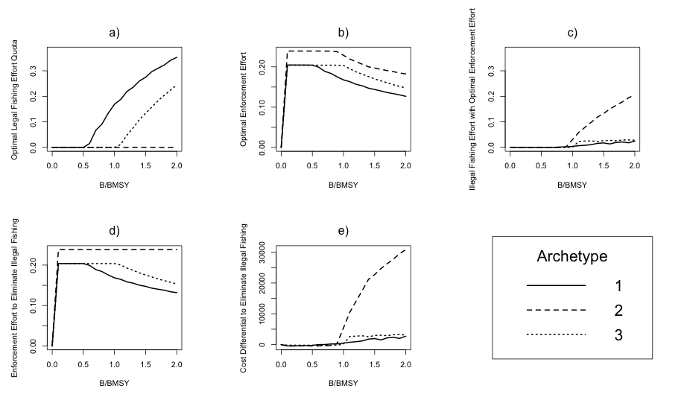

Figure 2: a) Optimal fishing effort quota given stock status B/BMSY; b) Optimal enforcement effort given stock status; and c) illegal fishing effort response given stock status; d) enforcement effort necessary to eliminate illegal fishing; and e) cost differential between optimal enforcement effort and enforcement effort necessary to eliminate illegal fishing. The stakeholder archetypes are defined as 1) fishing only; 2) dive tourism only; and 3) fishing and dive tourism.

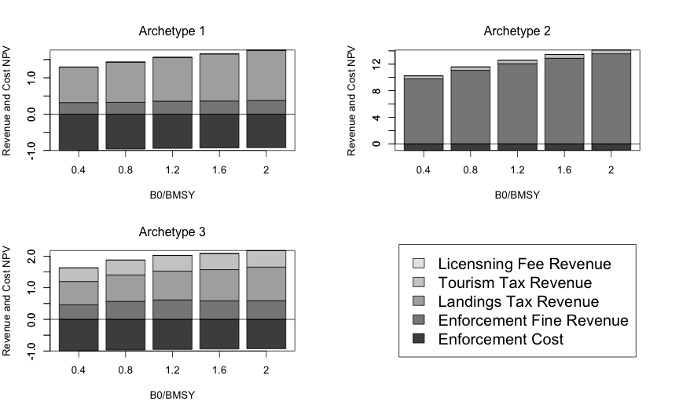

Figure 3: Net present value (NPV) of social planner cost and financing revenue streams over a twenty-year time horizon for various starting stock statuses (values are scaled to the NPV of the maximum enforcement cost for that particular archetype). The stakeholder archetypes are defined as 1) fishing only; 2) dive tourism only; and 3) fishing and dive tourism.

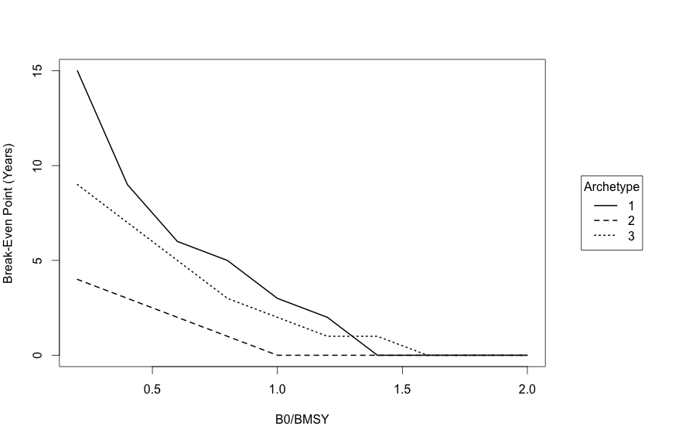

Figure 4: Break-even point for each archetype. The stakeholder archetypes are defined as 1) fishing only; 2) dive tourism only; and 3) fishing and dive tourism.

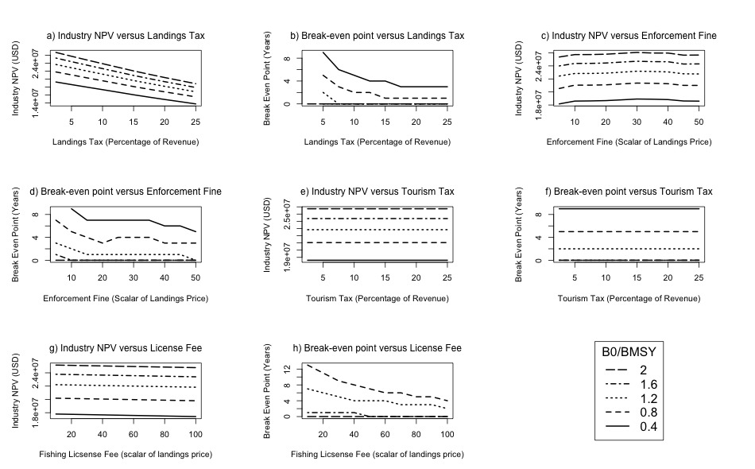

Figure 5: Archetype 1 sensitivity analysis for financing mechanisms (fishing industry only). a) Industry NPV versus Landings Tax; b) Break-even point versus Landings Tax; c) Industry NPV versus Enforcement Fine; d) Break-even point versus Enforcement Fine; e) Industry NPV versus Tourism Tax; f) Break-even point versus Tourism Tax; g) Industry NPV versus License Fee; and h) Break-even point versus License Fee.

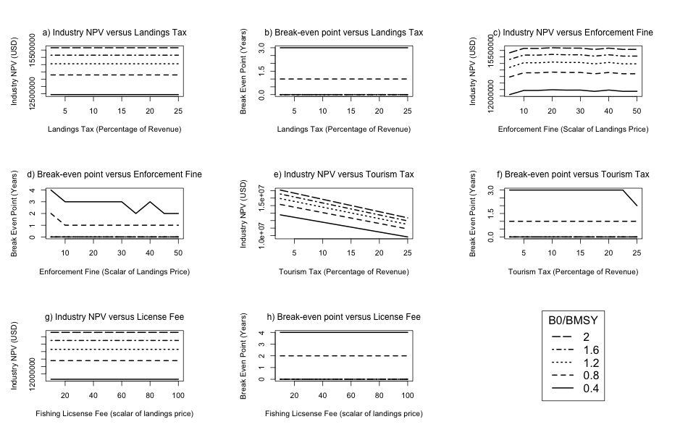

Figure 6: Archetype 2 sensitivity analysis for financing mechanisms (tourism industry only). a) Industry NPV versus Landings Tax; b) Break-even point versus Landings Tax; c) Industry NPV versus Enforcement Fine; d) Break-even point versus Enforcement Fine; e) Industry NPV versus Tourism Tax; f) Break-even point versus Tourism Tax; g) Industry NPV versus License Fee; and h) Break-even point versus License Fee.

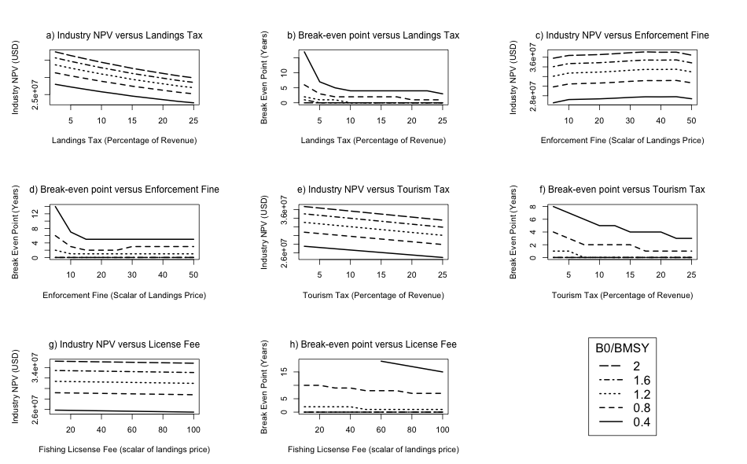

Figure 7: Archetype 3 sensitivity analysis for financing mechanisms (fishing and tourism industries). a) Industry NPV versus Landings Tax; b) Break-even point versus Landings Tax; c) Industry NPV versus Enforcement Fine; d) Break-even point versus Enforcement Fine; e) Industry NPV versus Tourism Tax; f) Break-even point versus Tourism Tax; g) Industry NPV versus License Fee; and h) Break-even point versus License Fee.

**9.0 Appendix**

*9.1 A1 - Estimation of Model Parameters*

The following section provides details on methods used to derive parameters presented in Table 1.

*9.1.1 Carrying Capacity (K)*

Information from the Barbuda spiny lobster fishery was used to estimate the carrying capacity (*K*) for a small-scale lobster fishery. At the time of the last assessment, it was determined that the Barbuda lobster fishery was being harvested at a sustainable level, (Horsfeld et al. 2013). Thus, annual landings were assumed to equal *MSY*. Data on total annual landings in the Barbuda lobster fishery were not available, but an approximation of total annual landings was calculated using known fishery parameters from Horsfeld et al. 2013 (Table 3):

*MSY = number of vessels * average trips per vessel per year * average catch per trip* (A*1*)

*K* was then calculated using the relationship*:*

$K= \frac{4MSY}{r}$ (A*2*)

*9.1.3* *Dive Tourism Industry Parameters*

Tourism parameters $α_{0}$ and $α_{1}$ in Equations 2, 3, and 4 are taken from Sala et al. 2013. $α_{2}$ is estimated by assuming that the maximum possible tourism revenue (generated when the stock is at carrying capacity (*K*)) should be equal to the maximum sustainable fishery revenue (generated when the legal catch is at *MSY*). By making this assumption, the fishing and tourism industries are normalized in order to draw more intuitive results from model simulations. No data was available to directly estimate approximate dive tourism revenue in a small-scale fishery setting.

*9.1.2 Detectability of Enforcement Parameters (a and b)*

The shape parameter *b* in Equation 11 is borrowed from the enforcement detectability of patrol vessels in the Kattegat and Skagerrak nephrops fishery (COBECOS 2009). The probability of a patrol vessel detecting illegal fishing was assumed to be proportional to the amount of area it is able to cover in a day. Assuming a speed of 15 knots per hour and a fishing area of 886 km2, one vessel could cover 22,240 m2 in 8 hours (assuming a vessel can cover a 22.5 km swath and an 11.25 m line of vision on either side of the vessel), or 25% of the total fishery area. It is therefore assumed that 3 patrol vessels would collectively be able to patrol 75% of the fishery area within 8 hours of surveillance at an enforcement effort of 1. Assuming fishers operate 24 hours per day, a maximum detection probability of 25% is found when enforcement effort is 1. It is assumed that vessels detected illegally fishing will be apprehended, prosecuted, and will receive a fine.